A

Project Work Report On

“ AI-Driven Synthetic Image Detection And Authenticity Analytics”

Submitted to

**SRI VENKATESWARA COLLEGE OF ENGINEERING AND TECHNOLOGY** **(AUTOMOMOUS)**

Affiliated to JNTUA, Anantapur

*In partial fulfillment of the requirements for the award of the degree of*

**BACHELOR OF TECHNOLOGY**

**IN**

**COMPUTER SCIENCE AND ENGINEERING (AI&ML)**

*during the academic year 2025-2026*

***Submitted by***

**T. DIVAKAR REDDY 22781A33C6**

**M. NIRUSHA 22781A3386**

**S. ASLAM BASHA 22781A33B4**

**S. JAMEEL AHAMAD 22781A33B7**

**V. MOHAN SAI 22781A33E2**

Under the esteemed guidance of

**Dr. K.NANDHA KUMAR MCA,M.TECH,PHD**

**Associate Professor**

**Department of CSE(AI&ML)**

**SRI VENKATESWARA COLLEGE OF ENGINEERING AND TECHNOLOGY(AUTONOMOUS)**

Affiliated to JNTUA, Anathapuramu-515002(A.P) & Approved by AICTE, New Delhi

Accredited by NAAC, Bengaluru & NBA, New Delhi

An ISO 9001:2000 Certified Institution

R.V.S. Nagar, Chittoor-517127(A.P), India www.svcetedu.org

**SRI VENKATESWARA COLLEGE OF ENGINEERING AND TECHNOLOGY**

**(AUTONOMOUS)**

**Affiliated to JNTUA, Anathapuramu-515002(A.P) & Approved by AICTE, New Delhi**

**Accredited by NAAC, Bengaluru & NBA, New Delhi**

**An ISO 9001:2000 Certified Institution**

**R.V.S. Nagar, Chittoor-517127(A.P), India**

[**www.svcetedu.org**](http://www.svcetedu.org)

 **CERTIFICATE**

This is to certify that, the project entitled, “**AI DRIVEN SYNTHETIC IMAGE DETECTION AND AUTHUNTICITY ANALYTICS”** is a bonafide work carried by the following students

**T. DIVAKAR REDDY 22781A33C6**

**M. NIRUSHA 22781A3386**

**S. ASLAM BASHA 22781A33B4**

**S. JAMEEL AHAMAD 22781A33B7**

**V. MOHAN SAI 22781A33E2**

in partial fulfillment of the requirement for the award of the degree **BACHELOR OF TECHNOLOGY in COMPUTER SCIENCE AND ENGINEERING (AI & ML)** during the academic year **2025-2026**

**SIGNATURE OF THE GUIDE SIGNATURE OF THE HOD**

**Dr. K.Nandha Kumar**, MCA, M. Tech, Ph.D. **Dr. M. Lavanya**, MCA, M. Tech, Ph.D.

Associate Professor HOD & Associate Professor

**INTERNAL EXAMINER EXTERNAL EXAMINIER**

Viva-Voce Conducted on

**SRI VENKATESWARA COLLEGE OF ENGINEERING AND TECHNOLOGY**

**(AUTONOMOUS)**

**Affiliated to JNTUA, Anathapuramu-515002(A.P) & Approved by AICTE, New Delhi**

**Accredited by NAAC, Bengaluru & NBA, New Delhi**

**An ISO 9001:2000 Certified Institution**

**R.V.S. Nagar, Chittoor-517127(A.P), India**

[**www.svcetedu.org**](http://www.svcetedu.org)

**Department of CSE(AI&ML)**

We T.DIVAKAR REDDY(22781A33C6), M.NIRUSHA(22781A3386), S.ASLAM BASHA(22781A33B4), S.JAMEEL AHAMAD(22781A33B7) and V.MOHAN SAI(22781A33E2) hereby declare that the Project Report entitled " **“AI-Driven synthetic image Detection and Authenticity Analytics"** under the guidance of **Dr. K.Nandha** **Kumar**, MCA, M.Tech, Ph.d, Sri Venkateswara College of Engineering & Technology (Autonomous), Chittoor is submitted in partial fulfillment of the requirements for the award of the degree of BACHELOR OF TECHNOLOGY in COMPUTER SCIENCE AND ENGINEERING(AI & ML).

This is a record of bonafied work carried out by us and the results embodied in this project have not been reproduced or copied from any source. The results embodied in this project report have not been submitted to any other university or institution for the award of any other degree or diploma.

**T.DIVAKAR REDDY 22781A33C6**

**M.NIRUSHA 22781A3386**

**S.ASLAM BASHA 22781A33B4**

**S.JAMEEL AHAMAD 22781A33B7**

**V.MOHAN SAI 22781A33E2**

**ACKNOWLEDGEMENT**

A Grateful thanks to **Dr .R. Venkata swamy**, Chairman, Sri Venkateswara College of Engineering and Technology for providing education in their esteemed institution.

We, wish to record our deep sense of gratitude and profound thanks to our beloved Vice Chairman, Sri. R.V. Srinivas for his valuable support throughout the course.

We, express our sincere thanks to **Dr. M. Mohan Babu**, our beloved principal for his encouragement and suggestions during the course of study.

We, wish to convey our gratitude and express our sincere thanks to our **Dr. M. Lavanya**, MCA, M.Tech, Ph.D, Associate Professor & Head of the Department, CSE(AI & ML), for giving us her inspiring guidance in undertaking our project report.

We express our sincere thanks to the Project Guide **Dr. K.Nandha Kumar**, MCA, M.Tech , Ph.D, Associate Professor , CSE(AI & ML) for his keen interest, stimulating guidance, encouragement with our work during all stages, to bring this project into fruition.

We, wish to convey our gratitude and express our sincere thanks to all Project Review Committee members for their support and cooperation rendered for successful submission of our project work. Finally, we would like to express our sincere thanks to all teaching, non-teaching faculty members, our parents, and friends and for all those who have supported us to complete the project work successfully.

**T.DIVAKAR REDDY 22781A33C6**

**M.NIRUSHA 22781A3386**

**S.ASLAM BASHA 22781A33B4**

**S.JAMEEL AHAMAD 22781A33B7**

**V.MOHAN SAI 22781A33E2**

.

** SRI VENKATESWARA COLLEGE OF ENGINEERING AND TECHNOLOGY**

**(AUTONOMOUS)**

**R.V.S. NAGAR, CHITTOOR-517 127, ANDHRA PRADESH DEPARTMENT OF COMPUTER SCIENCE AND ENGINEERING (AI & ML)**

**Vision and Mission of the Department under R20 Regulations**

**VISION**

●To achieve excellent standard of quality education by using latest tools in Artificial Intelligence and disseminating innovations to relevant areas.

**MISSION**

●To develop professionals who are skilled in Artificial Intelligence and Machine Learning.

●Impart rigorous training to generate knowledge through the state-of-the-art concepts and technologies in Artificial Intelligence and Machine Learning.

●Establish centers of excellence in leading areas of computing and artificial intelligence to inculcate strong ethical values, innovative research capabilities and leadership abilities in the young minds to work with a commitment to the progress of the nation.

** SRI VENKATESWARA COLLEGE OF ENGINEERING AND TECHNOLOGY**

**(AUTONOMOUS)**

**R.V.S. NAGAR, CHITTOOR-517 127, ANDHRA PRADESH DEPARTMENT OF COMPUTER SCIENCE AND ENGINEERING (AI & ML)**

**Program Educational Objectives (PEOs) under R20 Regulations**

**Program Educational Objectives (PEOs):**

**PEO1:** To be able to solve wide range of computing related problems to cater to the needs of industry and society.

**PEO2:** Enable students to build intelligent machines and applications with a cutting-edge combination of machine learning, analytics and visualization**.**

**PEO3:** Produce graduates having professional competence through life-long learning such as advanced degrees, professional skills and other professional activities related globally to engineering & society.

** SRI VENKATESWARA COLLEGE OF ENGINEERING AND TECHNOLOGY**

**(AUTONOMOUS)**

**R.V.S. NAGAR, CHITTOOR-517 127, ANDHRA PRADESH DEPARTMENT OF COMPUTER SCIENCE AND ENGINEERING (AI & ML)**

**Program Specific Outcomes (PSOs) under R20 Regulations**

**Program Specific Outcomes (PSOs):**

**PSO1:** Should have an ability to apply technical knowledge and usage of modern hardware and software tools related AI and ML for solving real world problems.

**PSO2:** Should have the capability to develop many successful applications based on machine learning methods, AI methods in different fields, including neural networks, signal processing, and data mining.

** SRI VENKATESWARA COLLEGE OF ENGINEERING AND TECHNOLOGY**

**(AUTONOMOUS)**

**R.V.S. NAGAR, CHITTOOR-517 127, ANDHRA PRADESH DEPARTMENT OF COMPUTER SCIENCE AND ENGINEERING (AI & ML)**

**PROGRAM OUTCOMES**

On successful completion of the Program, the graduates of B. Tech. CSE(AI&ML) Program will be able to:

1. Engineering knowledge: Apply the knowledge of mathematics, science, engineering fundamentals, and an engineering specialization to the solution of complex engineering problems.

2. Problem analysis: Identify, formulate, review research literature, and analyze complex engineering problems reaching substantiated conclusions using first principles of mathematics, natural sciences, and engineering sciences.

3. Design/development of solutions: Design solutions for complex engineering problems and design system components or processes that meet the specified needs with appropriate consideration for the public health and safety, and the cultural, societal, and environmental considerations.

4. Conduct investigations of complex problems: Use research-based knowledge and research methods including design of experiments, analysis and interpretation of data, and synthesis of the information to provide valid conclusions.

5. Modern tool usage: Create, select, and apply appropriate techniques, resources, and modern engineering and IT tools including prediction andmodeling to complex engineering activities with an understanding of the limitations.

6.The engineer and society: Apply reasoning informed by the contextual knowledge to assess societal, health, safety, legal and cultural issues and the consequent responsibilities relevant to the professional engineering practice.

7.Environment and sustainability: Understand the impact of the professional engineering solutions in societal and environmental contexts, and demonstrate the knowledge of, and need for sustainable development.

8.Ethics: Apply ethical principles and commit to professional ethics and responsibilities and norms of the engineering practice.

9.Individual and team work: Function effectively as an individual, and as a member or leader in diverse teams, and in multidisciplinary settings.

10.Communication: Communicate effectively on complex engineering activities with the engineering community and with society at large, such as, being able to comprehend and write effective reports and design documentation, make effective presentations, and give and receive clear instructions.

11.Project management and finance: Demonstrate knowledge and understanding of the engineering and management principles and apply these to one’s own work, as a member and leader in a team, to manage projects and in multidisciplinary environments.

12.Life-long learning: Recognize the need for, and have the preparation and ability to engage in independent and life-long learning in the broadest context of technological change.

**SRI VENKATESWARA COLLEGE OF ENGINEERING AND TECHNOLOGY**

**(Autonomous)**

**IV B.Tech II Semester CSE(AI& ML)**

**20ACM29: PROJECT WORK, SEMINAR AND INTERNSHIP IN INDUSTRY**

|  |  |  |  |  |  |  |  |  |  |
| --- | --- | --- | --- | --- | --- | --- | --- | --- | --- |
|  |  |  |  |  |  | **L** | **T** | **P** | **C** |
|  |  |  |  |  |  | **-** | **-** | **-** | **12** |

**COURSE OUTCOMES:**

After successful completion of this course, the students will be able to:

1. Create/Design computer science engineering systems or processes to solve complex computer science engineering and allied problems using appropriate tools and techniques following relevant standards, codes, policies, regulations and latest developments.

2. Consider society, health, safety, environment, sustainability, economics and project management in solving complex computer science engineering and allied problems.

3. Perform individually or in a team besides communicating effectively in written, oral and graphical forms on computer science engineering systems or processes.

# 

**ABSTRACT**

The rapid growth of digital image manipulation has increased the risk of fraudulent vehicle damage claims, making reliable image authenticity verification a critical requirement for insurance and automotive assessment systems. This project presents an **AI-driven vehicle damage detection and authenticity analytics web application** that leverages deep learning to classify vehicle damage images as **real or fake/manipulated**.

A convolutional neural network (CNN) is trained using a structured pipeline that includes dataset loading, data cleaning, exploratory data analysis, model training, and performance evaluation. The trained model analyzes visual cues such as **dents, scratches, cracks, surface deformations, and texture inconsistencies** to estimate the authenticity of vehicle damage images. During inference, the system generates a **probabilistic authenticity score** along with a binary classification result.

The proposed solution is deployed as a **Flask-based web application** that allows users to upload vehicle images for real-time analysis. A pretrained **MobileNetV2 model** is integrated to validate whether the uploaded image contains a vehicle before damage authenticity assessment. To enhance transparency and trust, the system provides **explainable predictions** through layer-wise feature map visualizations and automatically generated textual explanations describing the model’s decision process.

In addition, prediction results are stored for historical analysis and visualization through an interactive dashboard, enabling trend analysis and confidence tracking over time. The proposed system improves the reliability, interpretability, and efficiency of vehicle damage verification and offers a practical solution for reducing image-based insurance fraud and supporting automated automotive forensic analysis

|  |  |  |
| --- | --- | --- |
| **SL.NO** | **CONTENT** | **PAGE NO** |
| 1 | INTRODUCTION  1.1 PROBLEM STATEMENT | 1-2 |
| 2 | LITERATURE SURVEY | 3-4 |
| 3 | DATA COLLECTION | 5 |
| 4 | * 1. SYSTEM STUDY   2. 4.1 EXISTING SYSTEM   3. 4.2 PROPOSED SYSTEM   4. 4.3 SYSTEM ARCHITECTURE | 6-10 |
| 5 | METHODOLOGY  5.1 ALGORITHMS/MODELS USED  5.2OVERALL METHODOLOGY/DATAFLOW  5.3 USE CASES | 11--20 |
| 6 | IMPLEMENTATIONS | 21-22 |
| 7 | SYSTEM SPECIFICATIONS  7.1 HARDWARE SPECIFICATIONS  7.2 SOFTWARE SPEIFICATIONS  7.3 TOOLS AND FRAMEWORKS | 23-24 |
| 8 | EXPERIMENTAL SETUP & RESULTS  8.1 EXPERIMENTAL SETUP  8.2 RESULTS | 25-27 |
| 9 | CODING  9.1 MODEL TRAINING CODE  9.2 FLASK APP CODE | 28-40 |
| 10 | EXECUTION SCREENSHOTS | 41-44 |
| 11 | LIMITATIONS | 45 |
| 12 | FUTURE SCOPE | 46 |
| 13 | APPLICATIONS | 47 |
| 14 | SYSTEM TESTING | 48-49 |
| 15 | CONCLUSION | 50 |
| 16 | REERENCES | 51 |

**1.INTRODUCTION**

The rapid digitalization of insurance and automotive services has increased reliance on image-based vehicle damage assessment for claims and forensic analysis. Although this improves efficiency, it also introduces vulnerabilities, as advanced image editing and generative technologies make it easier to manipulate or fabricate vehicle damage images, leading to fraudulent insurance claims and inaccurate evaluations. Ensuring the authenticity of vehicle damage images has therefore become a critical challenge for insurance companies and automotive service providers.

Traditional damage assessment methods rely on manual inspection, which is time-consuming, subjective, and often ineffective in detecting subtle digital manipulations. Conventional rule-based image processing techniques also lack robustness across different vehicle types, lighting conditions, and damage patterns.

Recent advances in deep learning, particularly Convolutional Neural Networks (CNNs), enable automatic extraction of meaningful visual features such as textures, dents, scratches, and structural distortions. This project proposes an AI-based vehicle damage authenticity detection system that uses a CNN model to classify images as real or manipulated. A pretrained MobileNetV2 model first verifies vehicle presence, followed by authenticity analysis. The system is deployed as a Flask-based web application, providing real-time predictions, confidence scores, visual explanations, and an interactive dashboard for auditing and analysis.

**1.1 Problem Statement**

Overall, this project aims to provide a reliable, interpretable, and scalable solution for vehicle damage authenticity verification, reducing the risk of insurance fraud and supporting automated forensic analysis in real-world automotive application.

This project addresses this challenge by developing an **AI-driven vehicle damage detection and assessment web application** using a vehicle damage image dataset. With the increasing use of digitally altered and manipulated images in insurance claims and vehicle assessments, distinguishing **genuine vehicle damage images from fake or manipulated ones** has become a critical challenge for insurance companies, forensic investigators, and automotive service providers.

The project aims to develop a **deep learning-based model** that classifies vehicle damage images as **real or fake/manipulated** by analyzing discriminative visual features such as **dents, scratches, cracks, surface deformations, and texture distortions**. In addition to binary classification, the system generates an **authenticity score** representing the confidence of the prediction and provides **explainable visual and feature-based insights** that highlight the regions and cues influencing the model’s decision.

The proposed solution is deployed as a **web-based application**, allowing users to upload vehicle images and receive real-time predictions, authenticity scores, and explanations. This system enhances the reliability, transparency, and efficiency of vehicle damage verification, helping reduce fraudulent claims, improve forensic analysis, and support trustworthy automated decision-making in automotive and insurance domains

**2 LITERATURE SURVEY**

**A survey of insurance fraud detection using machine learning techniques**

**AUTHORS:** Phua C., Lee V., Smith K., Gayler R.

**ABSTRACT:**

Insurance fraud has become a major challenge for insurance companies, leading to significant financial losses every year. This paper presents a survey of different machine learning techniques used for detecting insurance fraud. Techniques such as decision trees, neural networks, support vector machines, and clustering methods are analyzed. The study highlights how data preprocessing, feature selection, and classification models help in identifying fraudulent claims efficiently. The survey concludes that machine learning-based approaches outperform traditional rule-based systems in fraud detection.

**b. ImageNet classification with deep convolutional neural networks**

**AUTHORS:** A. Krizhevsky, I. Sutskever, and G. E. Hinton

**ABSTRACT:**

This paper introduced deep convolutional neural networks (CNNs) for large-scale image classification. The model achieved significant improvement in accuracy by using multiple convolutional layers followed by fully connected layers. Techniques such as ReLU activation, dropout, and GPU acceleration were used to improve performance and reduce overfitting. The success of CNNs in image classification laid the foundation for their application in real-world problems such as document analysis and insurance fraud detection using images.

**c. Detection of fraudulent insurance documents using image processing techniques**

**AUTHORS:** S. Kumar, R. Verma, and P. Singh

**ABSTRACT:**

This work focuses on detecting fraud in insurance documents by applying image processing techniques. The proposed system involves preprocessing steps such as grayscale conversion, noise removal, normalization, and feature extraction. Features such as texture, shape, and structural patterns are analyzed to distinguish between genuine and fake documents. Experimental results show that image-based fraud detection improves accuracy when combined with machine learning classifiers.

**d. Convolutional neural network-based approach for insurance fraud detection**

**AUTHORS**: J. Wang, Y. Li, and H. Zhang

**ABSTRACT:**

This paper presents a CNN-based framework for detecting fraudulent insurance claims using image data. The model automatically learns discriminative features from claim-related images such as damaged vehicle photos

and scanned documents. The proposed approach reduces manual verification effort and improves detection accuracy. Results demonstrate that CNN-based models outperform traditional feature-based classifiers, making them suitable for large-scale insurance fraud detection systems.

**e. Image hashing techniques for duplicate and forged image detection**

**AUTHORS**: N. Monga and S. Gupta

**ABSTRACT:**

Image hashing techniques are used to detect duplicate or manipulated images by generating compact hash representations. This paper explains perceptual hashing methods such as average hash, difference hash, and perceptual hash. These techniques are useful in insurance fraud detection to identify repeated or altered claim images submitted by fraudsters. The study shows that image hashing combined with deep learning models enhances fraud detection accuracy.

**3.DATA COLLECTION**

In this project, a structured and multi-source data collection strategy was adopted to build a reliable dataset for detecting AI-generated (synthetic) images and analyzing image authenticity. The dataset consists of both real and AI-generated images, enabling the development of a deep learning model capable of distinguishing between authentic and synthetic visual content. Emphasis was placed on data diversity, quality, and accurate labeling to ensure robust model performance.

**1. Real Image Collection**

Authentic images were collected from publicly available and verified image datasets to ensure realism and quality. These images represent natural visual characteristics such as consistent textures, realistic lighting conditions, and sensor noise patterns typical of camera-captured images. Where applicable, images relevant to insurance claim scenarios, such as vehicles and damaged objects, were included to reflect real-world use cases. All real images were carefully reviewed to ensure the absence of synthetic or manipulated content.

**2. AI-Generated Image Collection**

Synthetic images were obtained from multiple AI image generation sources to capture a wide range of generative artifacts. These included images generated using modern generative models such as Generative Adversarial Networks (GANs) and diffusion-based models. Additionally, publicly available synthetic image datasets were utilized to ensure diversity in visual styles, resolutions, and generation techniques. This multi-source approach helps the model generalize to unseen AI-generated images.

**3. Data Labeling**

Each image in the dataset was accurately labeled into two primary classes: Real and FakeThe dataset was organized using structured **image paths**, where images were stored in separate directories corresponding to their labels (Real/Fake). In addition, a metadata file was maintained containing key attributes such as **image path**, **label**, and **vehicle damage information**..

**6. Dataset Organization**

The final dataset was organized into structured directories for efficient training and evaluation. Images were divided into training, validation, and testing subsets, ensuring no overlap between sets. This organization supports fair performance evaluation and prevents data leakage

**4.SYSTEM STUDY**

System study is a detailed analysis of the existing system and the proposed system to understand the problem domain, identify limitations, and define system requirements. In this project, the system study focuses on analyzing current insurance claim image verification processes and proposing an AI-driven solution to detect AI-generated and manipulated images used in fraudulent insurance claims.

With the increasing availability of AI image generation tools, insurance companies are facing a growing challenge in distinguishing real accident images from synthetic or manipulated ones. This necessitates an automated and intelligent system for image authenticity verification.

**4.1 Existing System**

In the existing insurance claim processing systems, vehicle damage image verification is primarily focused on **damage identification and assessment**, rather than **image authenticity verification**. Current systems assume that the uploaded claim images are genuine and concentrate on evaluating the extent and severity of visible damage.

**System Overview**

Existing systems rely on **manual inspection** and **damage detection–oriented computer vision models** to analyze vehicle images submitted during insurance claims. Human claim assessors or AI models inspect the images to identify dents, scratches, cracks, and other visible damages. These systems aim to automate damage localization, cost estimation, and claim settlement but lack mechanisms to verify whether the images themselves are real or synthetically generated.

**Key Components of the Existing System**

**1. Image Input and Submission**

Vehicle damage images are uploaded by customers or agents as part of the insurance claim process. These images are assumed to be authentic without automated validation.

**2. Manual Review and Rule-Based Verification**

Human experts visually inspect images to check for obvious inconsistencies. Some systems apply basic rule-based checks such as watermark validation, duplicate image detection, or simple integrity verification.

**3. Damage Detection Models**

Existing AI-based solutions utilize CNN-based object detection and segmentation models (such as YOLO, SSD, Faster R-CNN, or U-Net) to detect and localize vehicle damages. These models focus solely on identifying physical damage and estimating repair costs.

**4. Limited Fraud Checks**

Certain platforms perform basic fraud analysis using metadata consistency, historical claim comparison, or image reuse detection. However, these checks do not analyze pixel-level artifacts or generative patterns introduced by AI-based image synthesis.

**Limitations of the Existing System**

* No capability to classify images as **Real or Fake**
* Inability to detect **AI-generated or deepfake vehicle images**
* Heavy dependence on **manual verification**
* Absence of **authenticity confidence scoring**
* No explainability or visualization for fraud decisions
* Poor adaptability to emerging AI image generation techniques

**4.2 Proposed System**

The proposed system introduces an AI-driven vehicle image authenticity verification framework designed to automatically determine whether an uploaded vehicle damage image is Real or Fake (AI-generated/manipulated). Unlike existing systems that focus only on damage detection, the proposed solution emphasizes image authenticity analysis using deep learning.

**System Overview**

The system employs a Convolutional Neural Network (CNN)–based classification model trained on a labeled dataset containing real and AI-generated vehicle damage images. Upon image upload, the model analyzes visual patterns, texture inconsistencies, and pixel-level artifacts to determine the authenticity of the image. The system outputs a binary classification (Real/Fake) along with an authenticity confidence score and a visual explanation to support decision-making.

**Key Components of the Proposed System**

**1. Image Input Module**

Users upload vehicle damage images through the system interface. Images may originate from insurance claim submissions or inspection processes.

**2. Preprocessing Module**

Uploaded images are resized to a standardized resolution and normalized to match model input requirements. Noise reduction and image enhancement techniques are applied to improve feature consistency and robustness.

**3. CNN-Based Authenticity Detection**

A deep CNN model is trained using supervised learning to classify images into Real or Fake categories. The network automatically learns discriminative features such as:

* Texture irregularities
* Lighting and shadow inconsistencies
* Abnormal edge smoothness
* Frequency and noise artifacts introduced by AI generation

Transfer learning techniques may be applied to improve detection accuracy and reduce training time.

**4. Authenticity Score Generation**

In addition to binary classification, the system computes an authenticity score, representing the confidence level of the prediction. This score indicates the likelihood that the uploaded image is genuine, helping claim assessors evaluate risk more effectively.

**5. Explainability and Visualization**

To enhance trust and transparency, the system provides a visual explanation of the decision using feature activation maps (e.g., Grad-CAM). Highlighted regions indicate areas that influenced the model’s prediction, such as suspicious textures or unrealistic damage patterns.

6**. Analytics and Reporting**

The system logs predictions, confidence scores, and explanation data for further analysis. These insights assist insurance companies in identifying fraud trends and improving claim validation strategies.

**4.3 SYSTEM ARCHITECTURE**:

**1. Overall Architecture of the System**

The system follows a **modular and layered architecture** designed for vehicle damage authenticity detection. It integrates a user interface, deep learning models, explainability components, and data storage modules. The architecture ensures clear separation of responsibilities, allowing efficient validation, prediction, explanation, and result visualization within a Flask-based local environment.

**2. Description of System Components**

**User**

The user interacts with the system through a web interface. The user can:

* Upload vehicle images
* View authenticity prediction results
* Download analysis reports

**Web Interface (Flask-based)**

This component acts as the central controller of the system. Its main functions include:

* Accepting image uploads
* Validating images
* Forwarding images to AI models
* Displaying predictions and dashboards

**Vehicle Validator (MobileNetV2)**

This module uses a pretrained **MobileNetV2** model to:

* Verify whether the uploaded image contains a vehicle
* Reject invalid or non-vehicle images This step ensures reliable inputs for further processing.

**CNN Model**

The CNN model performs the **core authenticity analysis**. Its responsibilities include:

* Loading the trained CNN model
* Extracting damage-related features
* Predicting whether the damage is real or fake
* Generating a confidence score for the prediction

**Explanation Engine**

This module improves transparency by:

* Generating visual explanations such as feature maps
* Highlighting important regions influencing predictions
* Providing textual explanations of model decisions

**Database**

The database stores:

* Prediction resultsConfidence scores
* Image metadata It supports result retrieval for auditing and visualization.

**Dashboard**

The dashboard presents analytical insights to the user by:

* Displaying charts and trends
* Visualizing historical predictions
* Exporting reports in PDF format

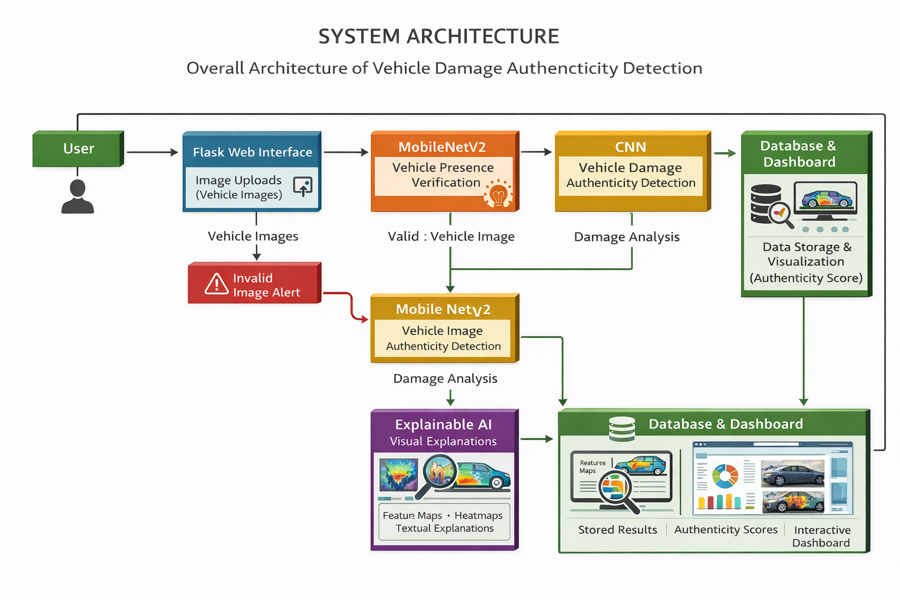

**5. METHODOLOGY**

The proposed system focuses on detecting the authenticity of vehicle damage images using deep learning techniques. The methodology integrates data preprocessing, convolutional neural network (CNN)–based feature learning, model evaluation, and a web-based deployment framework. Initially, vehicle damage images are collected and prepared to ensure data quality and consistency. A CNN model is trained to learn hierarchical visual features that distinguish genuine vehicle damage from manipulated or synthetic images. To improve reliability, a pretrained MobileNetV2 model is used to verify whether the uploaded image contains a vehicle before authenticity analysis. The trained model is deployed through a Flask-based web application, enabling real-time prediction, visualization of learned feature maps, and storage of prediction history for analysis. This structured approach enhances accuracy, interpretability, and real-world usability in insurance fraud detection systems.

**5.1. Algorithms / Models Used:**

The proposed system employs deep learning–based models to detect and verify the authenticity of vehicle damage images.

**A.MobilenetV2:**

MobileNet V2 is a powerful and efficient convolutional neural network architecture designed for mobile and embedded vision applications. Developed by Google, MobileNet V2 builds upon the success of its predecessor, MobileNet V1, by introducing several innovative improvements that enhance its performance and efficiency.

Key Features

* Inverted Residual Blocks: Enable efficient information flow by connecting layers with different depths, reducing computation.
* Linear Bottlenecks: Preserve important features by avoiding non-linear activation in low-dimensional layers.
* Depthwise Separable Convolutions: Split convolution into depthwise and pointwise operations, significantly reducing parameters and computation.
* ReLU6 Activation: Improves numerical stability for low-precision and mobile hardware.

**Architecture Overview**

* Input image size: 224 × 224 × 3
* Initial convolution followed by multiple inverted residual bottleneck blocks
* Expansion factor typically set to 6
* Final 1×1 convolution, global average pooling, and classification layer

**Advantages**

* High efficiency with low memory and computation
* Good accuracy on standard benchmarks
* Scalable and flexible for different performance needs
* Suitable for real-time mobile and edge deployment

**Applications**

* Image classification
* Object detection
* Semantic segmentation
* Face recognition
* Augmented reality

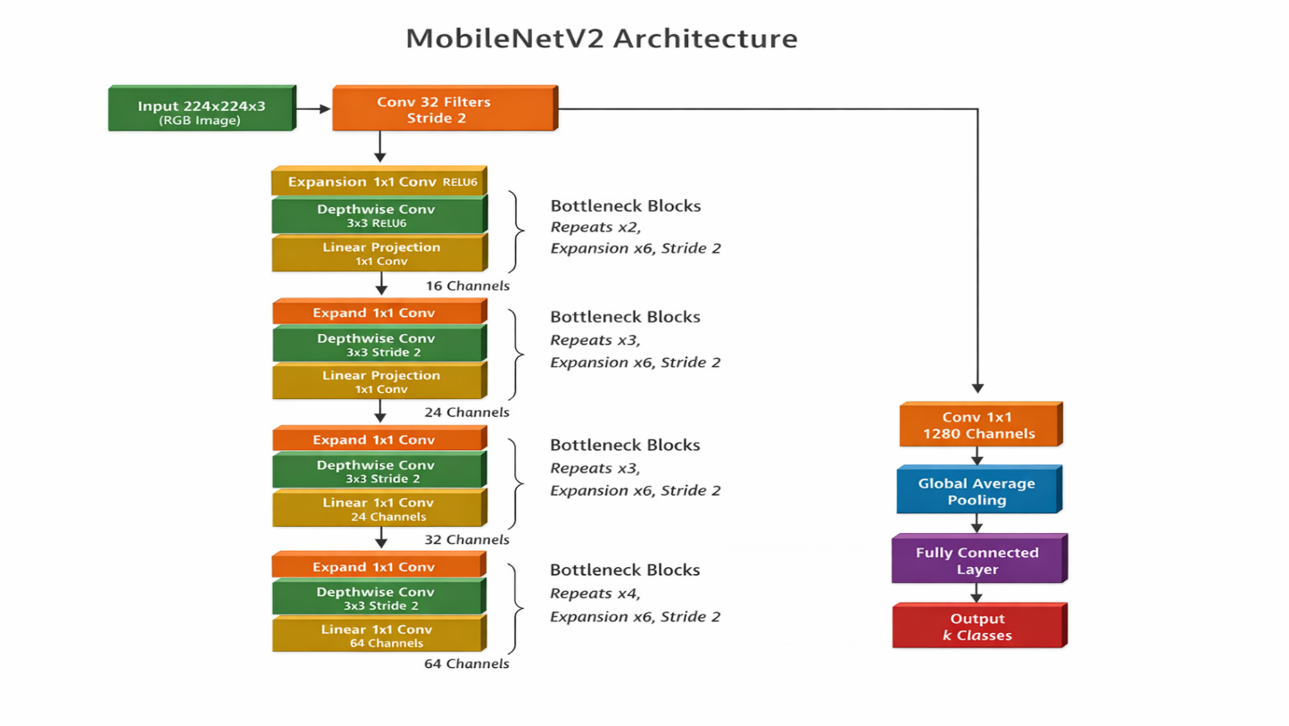

**B.Convolutional Neural Networks:**

A Convolutional Neural Network (CNN) is a specialized deep learning model designed for processing and analyzing visual data such as images and videos. CNNs are highly effective in image-based tasks because they automatically learn spatial and hierarchical features directly from raw pixel data, eliminating the need for manual feature extraction.

In the proposed vehicle damage authenticity detection system, a CNN is used to classify images as real damage or fake/manipulated damage by learning visual patterns such as dents, scratches, cracks, texture inconsistencies, and surface deformations.

**Key Components of CNN**

**1. Convolutional Layer**

The convolutional layer is the core building block of a CNN. It applies multiple learnable filters (kernels) over the input image to extract low-level features such as edges, corners, and textures. As the network deepens, convolutional layers learn more complex patterns like shapes, damage contours, and structural distortions.

Mathematically, convolution involves sliding a filter across the image and computing dot products to generate **feature maps**.

**2. Activation Function (ReLU)**

After convolution, a **Rectified Linear Unit (ReLU)** activation function is applied to introduce non-linearity. ReLU replaces negative values with zero, allowing the network to learn complex, non-linear relationships and improving training efficiency.

**3. Pooling Layer**

Pooling layers reduce the spatial dimensions of feature maps while retaining important information. **Max pooling** is commonly used to select the most prominent features, reducing computational cost and helping the model become invariant to small image translations.

**4. Feature Hierarchy Learning**

CNNs learn features hierarchically:

* Early layers learn edges and textures
* Middle layers learn damage shapes and patterns
* Deeper layers learn high-level representations distinguishing real and fake damage

This hierarchical learning makes CNNs well suited for visual authenticity analysis.

**5. Fully Connected Layer**

After feature extraction, the output feature maps are flattened and passed to fully connected (dense) layers. These layers perform high-level reasoning and classification by combining extracted features to predict the final class label (real or fake).

**6. Output Layer**

The output layer uses a **sigmoid or softmax activation function** to produce class probabilities. In this project, the CNN outputs an **authenticity score** indicating whether the vehicle damage image is genuine or manipulated.

**Advantages of CNN in This Project**

* Automatically learns discriminative visual features
* Robust to variations in lighting, angle, and vehicle type
* Effective in detecting subtle manipulation artifacts
* Reduces dependence on manual inspection
* Scalable and adaptable to real-world datasets

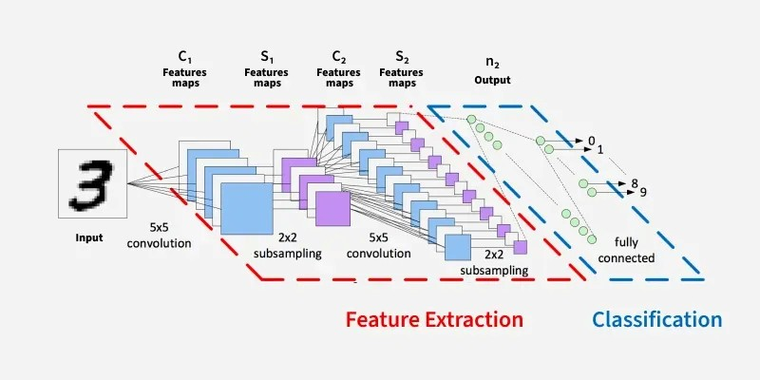

**5.2 Overall Methodological Approach**

The proposed system follows a supervised deep learning approach using Convolutional Neural Networks (CNNs). Instead of relying on manual inspection or rule-based checks, the system learns discriminative visual patterns directly from labeled vehicle damage images.

A pretrained MobileNetV2 model is first used to verify the presence of a vehicle in the uploaded image. Only validated vehicle images are forwarded to the authenticity detection module. A CNN-based classifier then analyzes visual artifacts to determine image authenticity.

The complete methodology is divided into the following major phases:

1. Data Collection
2. Data Preprocessing
3. Vehicle Verification
4. CNN-Based Model Training
5. Model Evaluation
6. System Deployment and Visualization

**1.Data Collection**

The first phase involves collecting a diverse dataset of vehicle damage images required for training and evaluation. The dataset consists of:

* Real vehicle damage images collected from verified and trusted sources
* Fake or AI-generated vehicle damage images created using generative models or obtained from synthetic datasets

Images cover different vehicle types, damage categories, lighting conditions, angles, and backgrounds. Each image is labeled into one of two classes: Real or Fake, ensuring reliable ground truth for supervised learning.

**2 Data Preprocessing**

Raw images often vary in size, quality, and format. To ensure consistency and improve model performance, preprocessing is performed as follows:

* Resizing images to a fixed resolution (224 × 224 × 3)
* Normalizing pixel values to a standard range
* Removing corrupted , duplicate images, blur images
* Enhancing image quality and reducing noise where required

These steps ensure uniform input representation and help the model learn meaningful visual patterns.

**3. Feature Engineering**

* Extracts meaningful visual features to differentiate real and fake vehicle damage images.
* Uses CNNs to capture textures, edges, dents, scratches, and lighting inconsistencies.
* Identifies manipulation artifacts and abnormal visual patterns.
* Helps detect subtle differences not easily visible to humans.
* Improves overall damage authenticity classification accuracy.

**4.Vehicle Verification Using MobileNetV2**

Before authenticity analysis, a pretrained MobileNetV2 model is used to verify whether the uploaded image contains a vehicle. This step prevents non-vehicle or irrelevant images from being processed.

* Images identified as non-vehicle are rejected
* Valid vehicle images are forwarded to the authenticity detection module

This verification step improves system reliability and reduces false predictions.

**5.CNN-Based Model Training**

A Convolutional Neural Network (CNN) is trained using the preprocessed and verified vehicle images. The CNN automatically learns hierarchical visual features such as:

* Dents, scratches, and cracks
* Texture and surface inconsistencies
* Lighting and shadow abnormalities
* Noise and frequency artifacts introduced by AI generation

The network consists of convolutional layers, ReLU activation functions, pooling layers, and fully connected layers. The final output layer produces a binary classification (Real/Fake) along with an authenticity confidence score.  
Supervised learning is used, and model parameters are optimized through iterative training.

**5. Model Evaluation**

To assess performance and generalization, the dataset is split into training and testing sets. The trained model is evaluated using standard performance metrics such as:

* Classification accuracy
* Precision, recall, and F1-score
* Confidence score reliability

Evaluation ensures that the system performs consistently across different vehicle types and damage scenarios.

**6. System Using Web Application**

After training and validation, the model is deployed through a Flask-based web application. The deployment workflow includes:

1. User uploads a vehicle damage image
2. Image preprocessing and vehicle verification
3. CNN-based authenticity prediction
4. Generation of authenticity score
5. Visualization of model explanations

The system provides real-time predictions in a user-friendly interface suitable for insurance claim processing.

**7.Explanaibility:**

Prediction results and metadata are stored in a database

* Historical predictions can be reviewed and analyzed
* Visual dashboards display results and trends

**5.3.Data Flow of the Vehicle Damage Authenticity Detection System :**

1. **Image Input:**

The user uploads a vehicle damage image through the web application.

1. **Vehicle Validation (MobileNetV2):**

The system checks whether the uploaded image actually contains a vehicle and rejects invalid images.

1. **Image Preprocessing:**

The image is resized and normalized to match the CNN model’s input format.

1. **Feature Extraction (CNN):**

The CNN extracts important visual features such as damage patterns and texture inconsistencies.

1. **Feature Map Generation:**

Intermediate feature maps are captured to show which image regions influence the prediction.

1. **Classification:**  
   The system classifies the image as Real or Fake and calculates an authenticity confidence score.
2. **Explanation Generation:**

A simple explanation is generated to describe why the image was classified as real or fake.

1. **Database Storage:**

Prediction results and image details are stored for future reference and analysis.

1. **Result and Visualization:**

The final prediction, confidence score, and visual explanations are displayed to the user.

1. **Dashboard and Analytics:**

Stored results are analyzed and shown as trends and statistics on an analytics dashboard.

**DATAFLOW SUMMARY:**

**User → Image Upload → Vehicle Check → Preprocessing → CNN Feature Extraction → Real/Fake Classification → Explanation → Database → Visualization**

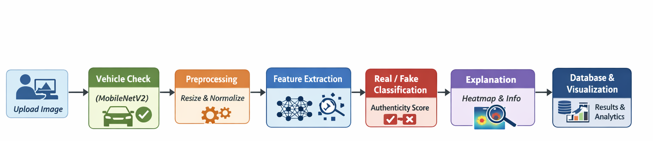

**FIG: DATAFLOW DIAGRAM OF VEHICLE DAMAGE DETECTION**

**5.3 Use Case Diagram**

A **Use Case Diagram** represents the functional behavior of the Vehicle Damage Authenticity Detection System by illustrating the interaction between users and the system. It provides a high-level view of the system’s functionality and shows how different actors achieve their goals through various use cases.

In the proposed system, the **primary actor** is the *User* (Insurance Officer / Investigator / End User), who interacts with the web application to verify the authenticity of vehicle damage images. The user uploads a vehicle damage image, which is then validated, processed, and classified by the system. The system also provides visual explanations, confidence scores, and maintains a history of predictions.

The **Admin** acts as a secondary actor responsible for monitoring system performance, viewing historical data, and analyzing trends through the dashboard.

**Actors**

* **User** – Uploads vehicle damage images and views authenticity results
* **Admin** – Monitors prediction history and dashboard analytics

**Use Cases**

* Upload Vehicle Damage Image
* Validate Vehicle Image (MobileNetV2)
* Preprocess Image
* Detect Damage Authenticity (CNN)
* View Prediction Result (Real / Fake)
* View Confidence Score
* View Feature Map Visualization
* Generate Explanation
* Store Prediction in Database
* View Dashboard Analytics
* View Prediction History

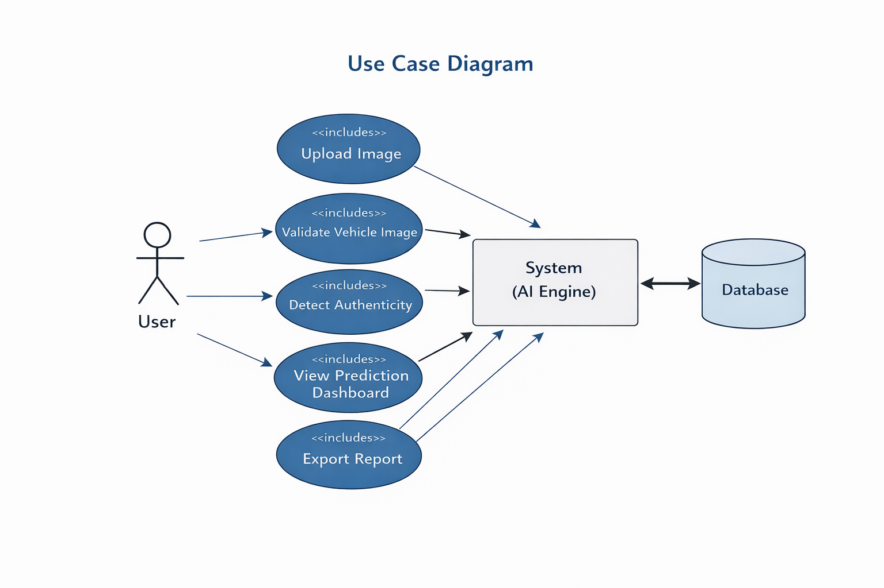

**Fig :** **Use Case Diagram for Vehicle Damage Authenticity Detection System**

**Use Case Description**

The user initiates the process by uploading a vehicle damage image through the web interface. The system first validates whether the image contains a vehicle using a pretrained MobileNetV2 model. If valid, the image is preprocessed and passed to the trained CNN model, which classifies the image as **Real** or **Fake**. The system then displays the prediction result along with a confidence score, feature map visualizations, and an automated explanation. All prediction details are stored in the database. The admin can access the dashboard to view historical predictions, confidence trends, and system analytics.

**6. Implementation**

Implementation is the phase where the proposed system design and methodology are transformed into a fully functional software solution. In this project, the implementation focuses on developing an AI-based Vehicle Damage Authenticity Detection System that automatically identifies whether an uploaded vehicle damage image is **Real or Fake (AI-generated/manipulated)**.

The system integrates image preprocessing, deep learning–based classification, explainability mechanisms, database storage, and a web-based user interface into a single cohesive application. The implementation is modular in nature to ensure clarity, scalability, and ease of maintenance. Each module performs a dedicated function and interacts with other modules to deliver accurate authenticity predictions along with confidence scores and explanations.

**Technology Stack Used**

The following technologies and tools were used to implement the proposed system:

* **Programming Language:** Python
* **Deep Learning Frameworks:** TensorFlow, Keras
* **Pretrained Model:** MobileNetV2 (for vehicle validation)
* **Web Framework:** Flask
* **Database:** MYSQL
* **Frontend Technologies:** HTML, CSS, JavaScript
* **Visualization Tools:** Matplotlib, Grad-CAM

**Data Handling and Preprocessing Implementation**

The implementation begins with handling and preparing the vehicle damage image dataset. Python scripts were developed to load image files along with their corresponding labels (Real/Fake) and metadata.

During preprocessing:

* Uploaded images are resized to **224 × 224 pixels**
* Pixel values are normalized to the range **[0, 1]**
* Invalid or corrupted images ,duplicated,blurry are filtered out
* Data is structured into labeled training and testing sets

**Feature Engineering Implementation**

Feature engineering is implemented using Convolutional Neural Networks, where features are automatically learned from image data. Instead of manual feature extraction, the CNN model derives high-level visual features such as:

* Texture inconsistencies
* Edge distortions and smoothness anomalies
* Lighting and shadow irregularities
* Dent, scratch, and surface deformation patterns
* AI-generated noise and artifact patterns

**Deep Learning Model Implementation**

A CNN-based deep learning model was implemented to perform binary classification of vehicle damage images into **Real** and **Fake** categories.

The model implementation includes:

* Splitting the dataset into training and testing sets
* Training the CNN using supervised learning
* Applying transfer learning where required
* Optimizing model parameters for improved accuracy
* Saving the trained model for reuse during deployment

Once trained, the model is loaded at runtime to perform predictions without the need for retraining.

**Web Application Implementation**

* Image upload interface for vehicle damage images
* Backend validation using MobileNetV2 for vehicle presence
* Integration with the trained CNN authenticity model
* Display of prediction result and confidence score
* Visualization of explanation maps

**Error Handling and Validation**

Basic error handling mechanisms were implemented to manage invalid inputs and system failures. Image validation ensures that only valid vehicle images are processed. If an invalid image is uploaded or a system error occurs, meaningful error messages are displayed to the user to maintain system reliability.

**7. SYSTEM SPECIFICATION**

The system specification defines the hardware, software, and technical requirements necessary to develop and deploy the Vehicle Damage Authenticity Detection System efficiently. This ensures reliable operation under real-world conditions.

**7.1 Hardware Requirements**

The proposed system can operate on standard computing systems without specialized hardware.

**Minimum Hardware Requirements:**

* **Processor:** Intel Core i3 or equivalent
* **RAM:** 4 GB
* **Storage:** 20 GB free disk space
* **System Type:** 64-bit
* **Input/Output Devices:** Keyboard, Mouse, Monitor

**Recommended Hardware Requirements:**

* **Processor:** Intel Core i5/i7 or AMD Ryzen
* **RAM:** 8–16 GB for model training, feature visualization, and handling large image datasets
* **Storage:** 50 GB SSD for faster access to datasets, model files, and uploaded images
* **GPU:** Optional; the system is optimized to run on CPU efficiently

These configurations are sufficient for image preprocessing, CNN model training, prediction, and web application deployment.

**7.2 Software Requirements**

**Operating System:**

* Windows 10 / 11 – Suitable for development and testing
* Linux (Ubuntu 20.04 or higher) – Preferred for deployment due to stability and performance
* macOS – Can be used for experimentation and development

**Programming Language:**

* Python 3.8 or above for backend logic, CNN model implementation, image processing, and web application development

**Development Tools:**

* IDE: Visual Studio Code, PyCharm, or Jupyter Notebook
* Version Control: Git for source code management and collaboration

**7.3 Libraries and Frameworks**

**Machine Learning & Deep Learning:**

* TensorFlow / Keras – Model building, training, and inference using CNN and MobileNetV2
* Scikit-learn – Evaluation metrics (accuracy, precision, recall, F1-score, confusion matrix, ROC–AUC)

**Data Processing & Image Handling:**

* NumPy – Numerical computations
* OpenCV / PIL – Image loading, resizing, and preprocessing
* imagehash – Detect visually similar or duplicate images

**Visualization:**

* Matplotlib ,seaborn – Feature maps, confidence trends, and analytical plots

**Web Framework:**

* Flask – Backend for web application and dashboard

**Front-End Technologies:**

* HTML – Defines webpage structure
* CSS – Styles webpage layout, colors, fonts, and responsiveness
* JavaScript – Adds interactivity and dynamic behavior

**Database:**

* MySQL – Stores uploaded image information, prediction results, confidence scores, and timestamps for historical analysis and auditing

**7.4 Functional Requirements**

The system must be capable of:

* Accepting image uploads of vehicles from users
* Verifying whether the uploaded image contains a vehicle
* Detecting and classifying vehicle damage as real or fake using CNN and MobileNetV2
* Displaying prediction results with confidence scores
* Maintaining historical records of uploaded images and prediction results

**7.5 Non-Functional Requirements**

* **Performance:** Predictions should be returned within 1–2 seconds
* **Usability:** Simple, intuitive interface accessible on desktop and mobile
* **Scalability:** Should support large image datasets and future model upgrades
* **Reliability:** Must handle invalid inputs or unsupported image formats gracefully

**8. EXPERIMENTAL SETUP AND RESULTS**

This chapter describes the experimental environment, dataset preparation, model training, evaluation metrics, and results obtained from the Vehicle Damage Authenticity Detection System. The experiments were conducted to evaluate the accuracy, reliability, and robustness of the CNN-based model under different image conditions.

**8.1 Experimental Setup**

The experimental setup defines the environment used to train and test the CNN model. All experiments were conducted on a standard computing system using open-source tools and libraries.

**8.1.1 Hardware Configuration**

* Processor: Intel Core i5 or equivalent
* RAM: 8 GB
* Storage: 50 GB available disk space
* System Type: 64-bit architecture

**8.1.2 Software Configuration**

* Operating System: Windows 10
* Programming Language: Python 3.9
* Development Environment: VS Code and Jupyter Notebook
* Machine Learning Libraries: TensorFlow, Keras, NumPy, Pandas, Scikit-learn
* Web Framework: Flask
* Database: MySQL

This configuration is sufficient to handle image preprocessing, CNN training, inference, and real-time prediction without performance issues.

**8.2 Dataset Description**

The dataset consists of vehicle damage images categorized as Real or Fake (manipulated). The images include various damage types such as dents, scratches, cracks, and surface distortions.

Key points about the dataset:

* Images are collected from publicly available datasets and manually curated sources.
* Labels: Real (1) and Fake (0)
* Preprocessing: Images are resized to 224×224 pixels, normalized, and filtered using MobileNetV2 to ensure only valid vehicle images are used.

**8.3 Data Splitting Strategy**

* Training Set: 70% of the data used for model training
* Validation Set: 15% used for evaluating generalization on unseen images
* Testing set: 15% used for the test the images

This ensures the CNN model learns representative patterns of real and manipulated vehicle damage images.

**8.4 Model Training Process**

The CNN model is trained offline using labeled images. Key steps include:

1. Loading preprocessed images and labels
2. Constructing the CNN architecture with convolutional, pooling, batch normalization, dropout, and dense layers
3. Training the model on the training set and validating on the validation set
4. Optimizing hyperparameters (learning rate, batch size, filters, dropout rate)
5. Saving the trained model for runtime inference

No GPU acceleration is used; the model is fully CPU-compatible.

**8.5 Evaluation Metrics**

To measure model performance, the following metrics are used:

* Accuracy: Overall correctness of predictions
* Precision: Correct real damage predictions / total predicted real
* Recall: Correct real damage predictions / total actual real
* F1-Score: Harmonic mean of precision and recall
* ROC Curve & AUC: Measures model’s discrimination ability between Real and Fake classes
* Confusion Matrix: Displays True Positives, True Negatives, False Positives, and False Negatives

**8.6 Experimental Results**

**8.6.1 Prediction Accuracy**

The CNN model accurately classifies vehicle damages, producing high confidence for real images and effectively identifying manipulated images. Confidence percentages and labels are displayed in the web interface.

**8.6.2 Real-Time Performance**

The system performs inference quickly on CPU, with image preprocessing, feature extraction, and prediction completed in seconds. This ensures practical deployment without specialized hardware.

**8.6.3 Explainability and Visualization**

Layer-wise CNN feature maps, confusion matrices, and ROC curves help users understand the decision-making process. This improves transparency and trust, especially for insurance and inspection applications.

**8.6.4 Dashboard Analysis**

Prediction results are stored in a MySQL database and visualized on an interactive dashboard:

* Pie charts show Real vs Fake distribution
* Bar and line charts display confidence trends and historical prediction patterns

**8.6.5 Statistical Consistency**

Stratified K-Fold validation shows consistent performance across different data splits. Fold-wise accuracies, mean accuracy, and standard deviation confirm model robustness.

**8.6.6 Robustness**

The system handles variations in image quality, backgrounds, and lighting conditions. MobileNetV2 pre-validation ensures only valid vehicle images are processed, reducing false predictions.

**9.Coding**

**9.1 Model Training:**

import os

    import cv2

    import numpy as np

    import pandas as pd

    import warnings

from sklearn.model_selection import train_test_split

    from sklearn.preprocessing import LabelEncoder

from tensorflow.keras.models import Sequential

    from tensorflow.keras.layers import (

        Conv2D, MaxPooling2D, Flatten,

        Dense, Dropout, BatchNormalization

    )

    from tensorflow.keras.optimizers import Adam

    from tensorflow.keras.preprocessing.image import ImageDataGenerator

    from tensorflow.keras.callbacks import EarlyStopping

# =================================================

    # SUPPRESS WARNINGS

    # =================================================

    os.environ["TF_CPP_MIN_LOG_LEVEL"] = "3"

    warnings.filterwarnings("ignore")

    # =================================================

    # PATHS

    # =================================================

    BASE_DIR = r"D:\INSURENCEFRAUDDETECTION"

    CSV_PATH = os.path.join(BASE_DIR, "dataset", "processed", "labels_clean_final.csv")

    IMAGE_ROOT = os.path.join(BASE_DIR, "dataset", "raw", "vehicle_damage_dataset")

    IMG_SIZE = (224, 224)

    BATCH_SIZE = 32

    EPOCHS = 10

    RANDOM_STATE = 42

TRAIN_SIZE = 0.70

    VAL_SIZE   = 0.15

    TEST_SIZE  = 0.15

# =================================================

# LOAD CSV

    # =================================================

    df = pd.read_csv(CSV_PATH)

    print("✅ CSV Loaded:", df.shape)

# Ensure class column exists

    if "class" not in df.columns:

        df["class"] = df["image_path"].apply(

            lambda x: "real" if x.lower().startswith("real") else "fake"

        )

# Encode labels

    le = LabelEncoder()

    df["label"] = le.fit_transform(df["class"])

    print("Class mapping:", dict(zip(le.classes_, le.transform(le.classes_))))

  # ================================================

# TRAIN / VAL / TEST SPLIT (SINGLE SPLIT)

    # =================================================

    train_df, temp_df = train_test_split(

        df,

        test_size=(1 - TRAIN_SIZE),

        stratify=df["label"],

        random_state=RANDOM_STATE

    )

    val_ratio = VAL_SIZE / (VAL_SIZE + TEST_SIZE)

val_df, test_df = train_test_split(

        temp_df,

        test_size=(1 - val_ratio),

        stratify=temp_df["label"],

        random_state=RANDOM_STATE

    )# =================================================

    # SPLIT SUMMARY

    # =================================================

    total = len(df)

    print("\n✅ DATASET SPLIT SUMMARY")

    print(f"Total Samples : {total}")

    print(f"Train         : {len(train_df)} ({len(train_df)/total*100:.2f}%)")

    print(f"Validation    : {len(val_df)} ({len(val_df)/total*100:.2f}%)")

    print(f"Test          : {len(test_df)} ({len(test_df)/total*100:.2f}%)")

train_datagen = ImageDataGenerator(

        rescale=1./255,

        rotation_range=25,

        width_shift_range=0.1,

        height_shift_range=0.1,

        zoom_range=0.2,

        shear_range=0.1,

        horizontal_flip=True,

        fill_mode="nearest"

    )

val_test_datagen = ImageDataGenerator(rescale=1./255)

train_gen = train_datagen.flow_from_dataframe(

        train_df,

        directory=IMAGE_ROOT,

        x_col="image_path",

        y_col="class",

        target_size=IMG_SIZE,

        batch_size=BATCH_SIZE,

        class_mode="binary",

        shuffle=True

    )

val_gen = val_test_datagen.flow_from_dataframe(

        val_df,

        directory=IMAGE_ROOT,

        x_col="image_path",

        y_col="class",

        target_size=IMG_SIZE,

  batch_size=BATCH_SIZE,

        class_mode="binary",

        shuffle=False

    )

    test_gen = val_test_datagen.flow_from_dataframe(

        test_df,

        directory=IMAGE_ROOT,

        x_col="image_path",

        y_col="class",

        target_size=IMG_SIZE,

        batch_size=BATCH_SIZE,

        class_mode="binary",

        shuffle=False

    )

# =================================================

    # BUILD CNN MODEL (REDUCED COMPLEXITY) # =================================================

    def build_cnn_model(input_shape=(224,224,3)):

        model = Sequential()

        model.add(Conv2D(32, (3,3), activation="relu", padding="same", input_shape=input_shape))

        model.add(BatchNormalization())

        model.add(MaxPooling2D(2,2))

model.add(Conv2D(64, (3,3), activation="relu", padding="same"))

        model.add(BatchNormalization())

        model.add(MaxPooling2D(2,2))

model.add(Conv2D(128, (3,3), activation="relu", padding="same"))

        model.add(BatchNormalization())

        model.add(MaxPooling2D(2,2))

model.add(Flatten())

        model.add(Dense(128, activation="relu"))   # 🔽 reduced

        model.add(Dropout(0.6))                    # 🔼 increased

model.add(Dense(1, activation="sigmoid"))

model.compile(

            optimizer=Adam(1e-4),

            loss="binary_crossentropy",

            metrics=["accuracy"]

        )

        return model

model = build_cnn_model()

    model.summary()

    # =================================================

    # EARLY STOPPING (KEY OVERFITTING FIX)

    # =================================================

    early_stop = EarlyStopping(

        monitor="val_loss",

        patience=3,

        restore_best_weights=True

    )

    # =================================================

    # TRAIN MODEL

    # =================================================

    history = model.fit(

        train_gen,

        validation_data=val_gen,

        epochs=EPOCHS,

        callbacks=[early_stop],

        verbose=2

    )

# =================================================

    # EVALUATE ON TEST SET

    # =================================================

    test_loss, test_acc = model.evaluate(test_gen, verbose=0)

    print("\n📊 TEST SET PERFORMANCE")

    print(f"Test Accuracy : {test_acc*100:.2f}%")

    print(f"Test Loss     : {test_loss:.4f}")

# =================================================

    # SAVE MODEL

    # =================================================

    os.makedirs("saved_models", exist_ok=True)

    model.save("saved_models/final_cnn_model.h5")

    print("\n Model saved at saved_models/final_cnn_model.h5")

**FLASK APP CODE:**

from db_operations import save_prediction, fetch_predictions

import os

import numpy as np

import matplotlib.pyplot as plt

from flask import Flask, render_template, request, session

from tensorflow.keras.models import load_model, Model

from tensorflow.keras.preprocessing import image

from tensorflow.keras.applications.mobilenet_v2 import (

    MobileNetV2, preprocess_input, decode_predictions

)

# ------------------ CONFIG ------------------

UPLOAD_FOLDER = "static/uploads"

FEATURE_FOLDER = "static/feature_maps"

CNN_MODEL_PATH = "saved_models/final_cnn_model.h5"

IMG_SIZE = 224

SECRET_KEY = "your-secret-key"

os.makedirs(UPLOAD_FOLDER, exist_ok=True)

os.makedirs(FEATURE_FOLDER, exist_ok=True)

# ------------------ FLASK APP ------------------

app = Flask(__name__)

app.config["UPLOAD_FOLDER"] = UPLOAD_FOLDER

app.secret_key = SECRET_KEY

# ------------------ LOAD CNN MODEL ------------------

cnn_model = load_model(CNN_MODEL_PATH)

print("✅ CNN Model loaded successfully")

# ------------------ FEATURE MAP MODEL ------------------

conv_layers = [layer.output for layer in cnn_model.layers if "conv" in layer.name.lower()]

feature_model = Model(inputs=cnn_model.input, outputs=conv_layers)

# ------------------ LAYER DESCRIPTIONS ------------------

LAYER_DESCRIPTIONS = {

    "conv_layer_1": "Detects basic edges, contours, and structural outlines of the vehicle.",

    "conv_layer_2": "Extracts texture inconsistencies, cracks, lighting variations, and shadows.",

    "conv_layer_3": "Identifies complex damage regions and synthetic manipulation artifacts."

}

# ------------------ AUTO EXPLANATION ------------------

def generate_explanation(pred):

    explanation = ["Input image resized to 224×224 and normalized."]

    if pred >= 0.7:

        explanation += [

            "Strong structural consistency detected.",

            "Damage patterns match real accident images.",

            "High confidence in image authenticity."

        ]

    elif pred >= 0.5:

        explanation += [

            "Moderate consistency in damage patterns.",

            "Some ambiguity detected in texture regions."

        ]

    else:

        explanation += [

            "Irregular textures and unnatural edges detected.",

            "High probability of image manipulation."

        ]

    explanation.append("CNN combined multi-level features to make final decision.")

    return explanation

# ------------------ SAVE FEATURE MAPS ------------------

def save_feature_maps(feature_maps):

    saved_images = {}

    for idx, fmap in enumerate(feature_maps):

        layer_name = f"conv_layer_{idx + 1}"

        layer_dir = os.path.join(FEATURE_FOLDER, layer_name)

        os.makedirs(layer_dir, exist_ok=True)

        saved_images[layer_name] = []

        for i in range(min(6, fmap.shape[-1])):

            img = fmap[0, :, :, i]

            img = (img - img.min()) / (img.max() - img.min() + 1e-6)

            img_path = f"{layer_dir}/{layer_name}_{i}.png"

            plt.imsave(img_path, img, cmap="gray")

            saved_images[layer_name].append(img_path)

    return saved_images

# ------------------ VEHICLE CHECK (MobileNetV2) ------------------

vehicle_model = MobileNetV2(weights="imagenet", include_top=True)

def is_vehicle(img_path, threshold=0.15):

    img = image.load_img(img_path, target_size=(224, 224))

    img_array = image.img_to_array(img)

    img_array = np.expand_dims(img_array, axis=0)

    img_array = preprocess_input(img_array)

    preds = vehicle_model.predict(img_array)

    decoded = decode_predictions(preds, top=10)[0]

    VEHICLE_KEYWORDS = [

        "car", "jeep", "cab", "taxi",

        "truck", "bus", "pickup",

        "van", "minivan",

        "bumper", "grille", "headlight",

        "automobile", "sedan"

    ]

    for _, label, prob in decoded:

        if any(k in label.lower() for k in VEHICLE_KEYWORDS) and prob >= threshold:

            return True, label, float(prob)

    return False, None, None

# ------------------ HOME PAGE ------------------

@app.route("/", methods=["GET", "POST"])

def index():

    result = None

    img_path = None

    explanation = []

    feature_images = {}

    invalid_message = None

    if request.method == "POST":

        file = request.files.get("image")

        if file and file.filename:

            img_path = os.path.join(app.config["UPLOAD_FOLDER"], file.filename)

            file.save(img_path)

            # Step 1: Vehicle Validation

            is_valid, vehicle_label, vehicle_conf = is_vehicle(img_path)

            if not is_valid:

                invalid_message = "⚠️ Please upload a valid vehicle damage image."

            else:

                img = image.load_img(img_path, target_size=(IMG_SIZE, IMG_SIZE))

                img_array = image.img_to_array(img) / 255.0

                img_array = np.expand_dims(img_array, axis=0)

                pred = float(cnn_model.predict(img_array)[0][0])

                authenticity = round(pred * 100, 2)

                manipulation = round((1 - pred) * 100, 2)

                result = {

                    "label": "REAL" if pred >= 0.5 else "FAKE",

                    "authenticity": authenticity,

                    "manipulation": manipulation,

                    "vehicle": vehicle_label,

                    "vehicle_confidence": round(vehicle_conf * 100, 2)

                }

                # Save to database

                try:

                    save_prediction(

                        image_name=file.filename,

                        prediction=result["label"],

                        confidence=authenticity

                    )

                except Exception as e:

                    print("Database Error:", e)

                # Feature maps

                feature_maps = feature_model.predict(img_array)

                feature_images = save_feature_maps(feature_maps)

                # Explanation

                explanation = generate_explanation(pred)

                # Save session data

                session["latest_uploaded_image"] = file.filename

                session["latest_confidence"] = authenticity

                session["latest_explanation"] = explanation

                session["latest_feature_images"] = feature_images

    return render_template(

        "index.html",

        result=result,

        img_path=img_path,

        explanation=explanation,

        feature_images=feature_images,

        layer_descriptions=LAYER_DESCRIPTIONS,

        invalid_message=invalid_message

    )

# ------------------ DASHBOARD PAGE ------------------

@app.route("/dashboard")

def dashboard():

    history = fetch_predictions()

real_count = sum(1 for row in history if row[2] == "REAL")

    fake_count = sum(1 for row in history if row[2] == "FAKE")

    confidences = [float(row[3]) for row in history]

    time_labels = [row[4] for row in history]

    real_trend, fake_trend = [], []

    real_total = fake_total = 0

for row in history:

        if row[2] == "REAL":

            real_total += 1

        else:

            fake_total += 1

        real_trend.append(real_total)

        fake_trend.append(fake_total)

    uploaded_image_url = (

        f"/static/uploads/{session.get('latest_uploaded_image')}"

        if session.get("latest_uploaded_image")

        else None

    ) return render_template(

        "dashboard.html",

        history=history,

        real_count=real_count,

        fake_count=fake_count,

        confidences=confidences,

        time_labels=time_labels,

        real_trend=real_trend,

        fake_trend=fake_trend,

        uploaded_image_url=uploaded_image_url,

        confidence_score=session.get("latest_confidence"),

        explanation_text=session.get("latest_explanation", ["No explanation available"]),

        feature_images=session.get("latest_feature_images", {}),

        layer_descriptions=LAYER_DESCRIPTIONS

    )

# ------------------ DATABASE PAGE ------------------

@app.route("/database")

def database():

    history = fetch_predictions()

    return render_template("database.html", history=history)

# ------------------ MAIN ------------------

if __name__ == "__main__":

    app.run(debug=True)

**10.EXECUTION SCREENSHOTS**

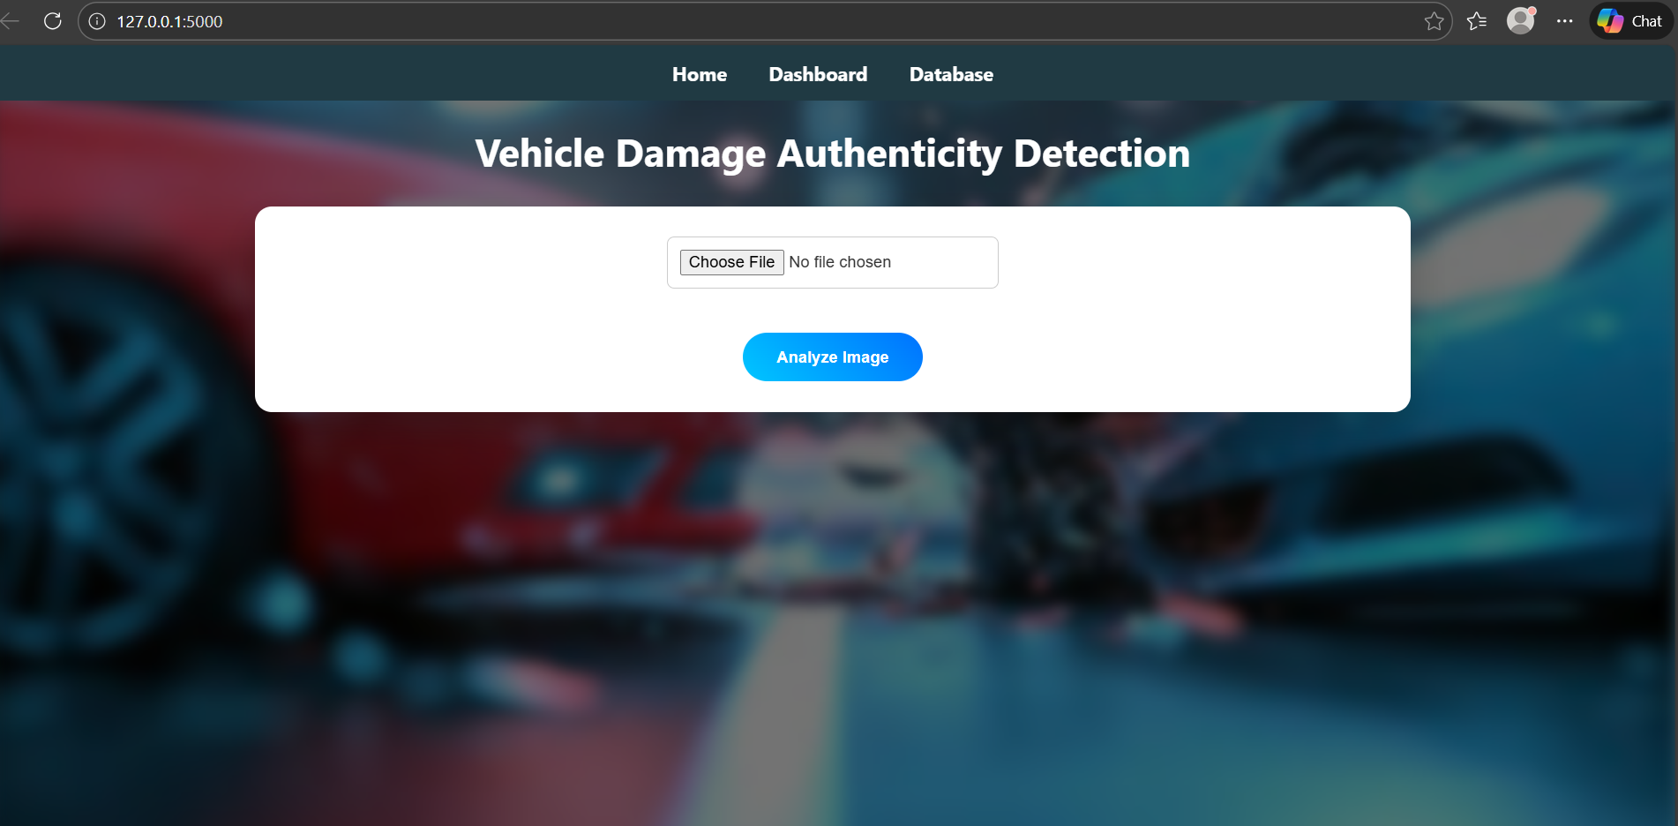

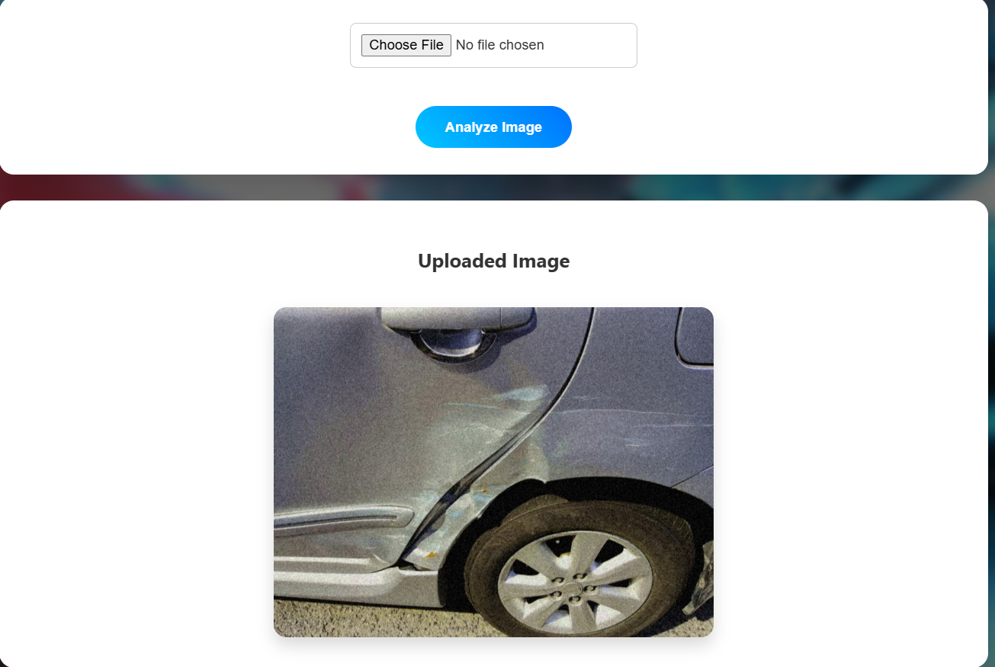

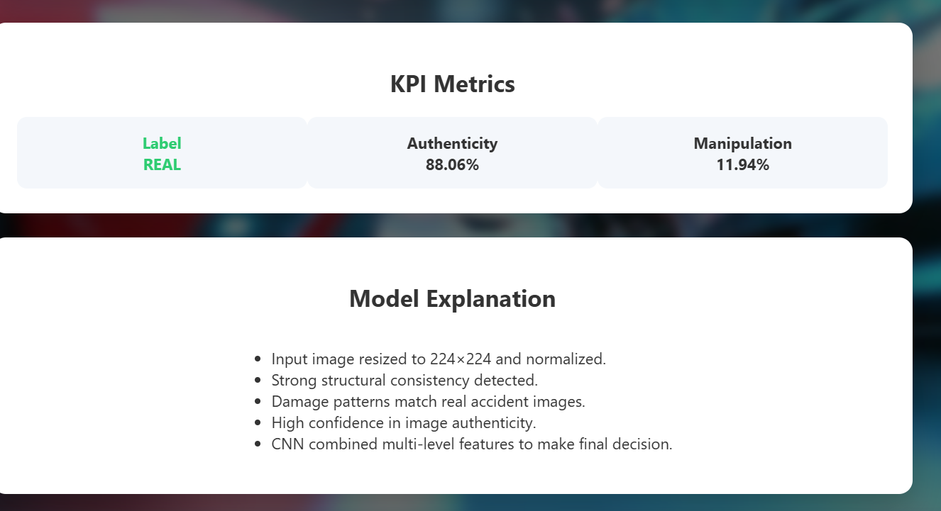

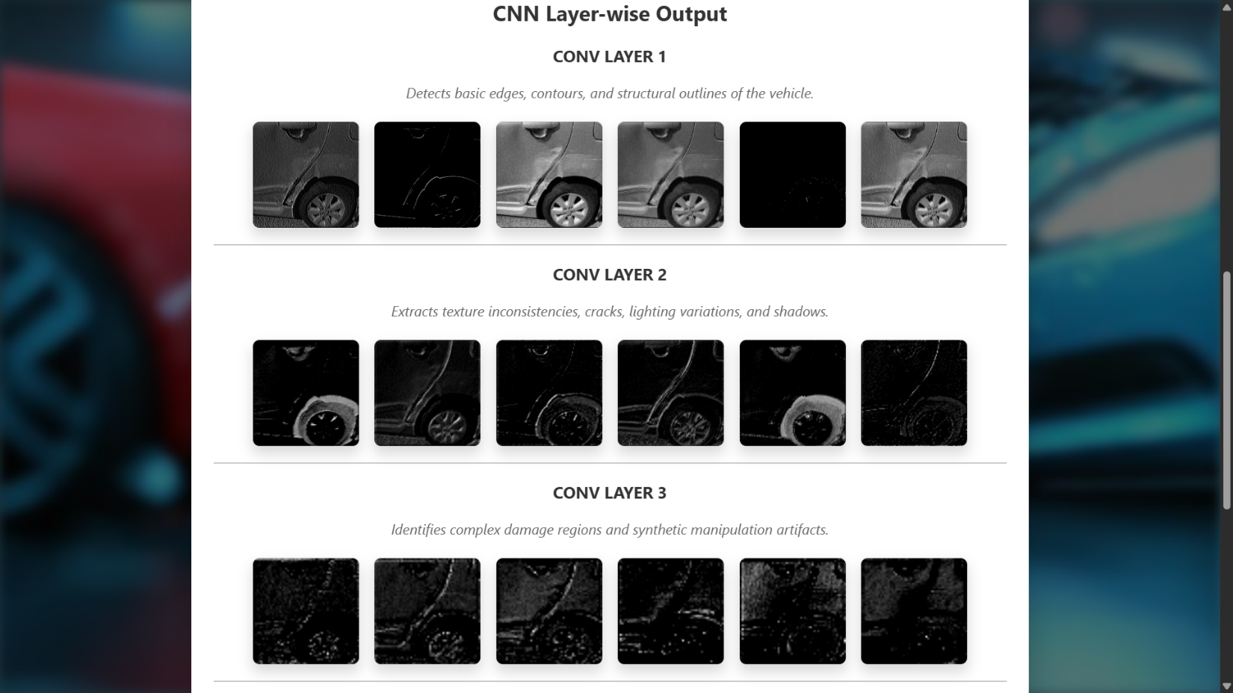

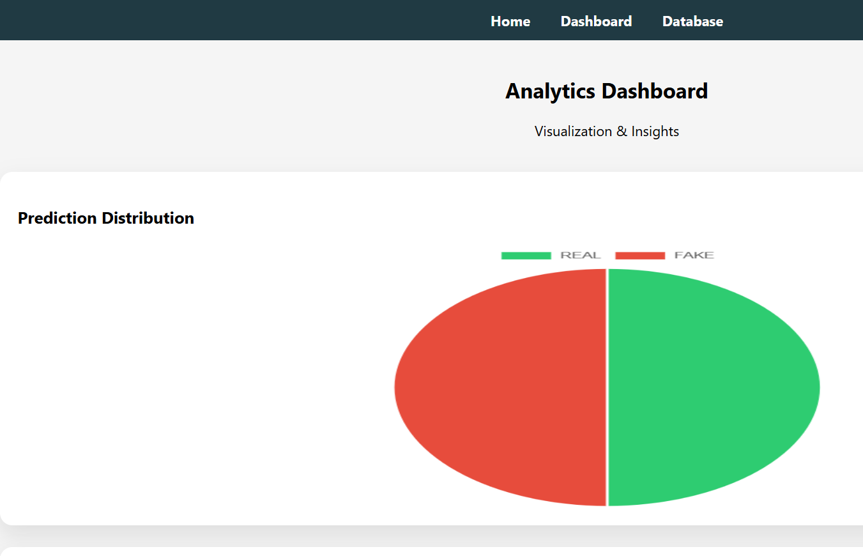

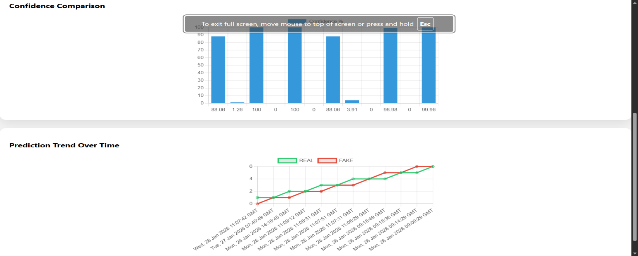

**11. LIMITATIONS OF THE PROJECT**

1. **Limited Dataset Diversity:**The performance of the CNN model depends heavily on the quality and diversity of the training dataset. Since the dataset contains a limited number of vehicle types, damage patterns, and manipulation styles, the model may not generalize perfectly to all real-world vehicle images or newly emerging image editing techniques.
2. **Binary Classification Constraint:**The system classifies vehicle damage images only into two categories: REAL and FAKE. It does not identify the specific type of manipulation or quantify the severity of tampering, which limits the depth of forensic analysis.
3. **CPU-Based Processing:**The model is executed entirely on a CPU without GPU acceleration. While this improves system compatibility, it increases inference time for large images and restricts scalability when handling multiple concurrent user requests.
4. **Dependence on Image Quality:**Prediction accuracy may degrade when images are highly blurred, poorly lit, low-resolution, or captured at extreme angles. Such conditions can obscure critical visual features required by the CNN for accurate authenticity detection.
5. **Threshold Sensitivity:**The final classification depends on a predefined probability threshold. Slight variations around this threshold can influence the final label and confidence score, which may occasionally lead to borderline misclassifications.
6. **Limited Manipulation Detection Scope:**The CNN primarily learns visual inconsistencies present in the training data. Advanced image manipulations, such as AI-generated deepfake images or sophisticated retouching techniques unseen during training, may not always be detected accurately.
7. **No Real- Time Video- Analysis:**The system processes only static images uploaded by users. It does not support real-time video streams or continuous frame analysis, which limits its applicability in live vehicle inspection scenarios.
8. **Manual Image Upload Dependency:**The current implementation relies on manual image uploads through the web interface. Automated image capture, batch processing, or integration with insurance claim systems is not implemented.

**12. FUTURE SCOPE**

1. **Multi-Class Damage and Manipulation Detection**

The current system performs binary classification (REAL / FAKE). In the future, it can be extended to identify **specific types of image manipulation**, such as copy–move forgery, splicing, retouching, or AI-generated damage, enabling more detailed forensic analysis.

1. **Severity Estimation of Vehicle Damage**

The model can be enhanced to estimate the **severity level of vehicle damage** (minor, moderate, severe) in addition to authenticity detection. This would be highly useful for insurance claim assessment and cost estimation.

1. **Integration of Advanced Explainability Techniques**

Future versions can incorporate explainable AI methods such as **Grad-CAM, saliency maps, or attention mechanisms** to precisely highlight manipulated regions and improve transparency and trust in predictions.

1. **GPU Acceleration and Model Optimization**

Deploying the system on **GPU-enabled environments** and optimizing the CNN architecture using pruning or quantization can significantly reduce inference time and allow real-time or large-scale deployment.

1. **Support for Real-Time Video Analysis**

The system can be extended to analyze **video streams or live camera feeds**, enabling real-time vehicle inspection at service centers, toll booths, or insurance verification points.

1. **Mobile and Cloud-Based Deployment**

The application can be deployed as a **mobile app** or hosted on cloud platforms such as AWS or Azure, allowing users to capture images directly from mobile devices and receive instant predictions.

1. **Automated Insurance Claim Processing**

Future enhancements can integrate the system with **insurance databases and claim management systems**, enabling automated verification, fraud detection, and report generation.

1. **Scalable Backend Architecture**

Migrating from Flask to a more scalable framework or adding microservices, authentication, and load balancing can support **multi-user and enterprise-level deployments**.

1. **Continuous Learning and Model Updates**

The system can adopt **online learning or periodic retraining** using newly collected data to continuously improve performance and adapt to evolving manipulation techniques.

**13.Applications**

**Insurance Claim Verification:**

The system can be used by insurance companies to automatically verify the authenticity of vehicle damage images submitted by customers. This helps reduce fraudulent claims, speeds up claim approval, and minimizes manual inspection efforts.

**Automotive Damage Assessment:**

Vehicle service centers and automobile dealerships can use the system to assess damage authenticity during vehicle servicing, resale evaluation, and warranty claim processing, ensuring fair and accurate assessments.

**Forensic and Legal Investigations:**

Law enforcement agencies and forensic experts can utilize the model to analyze suspected manipulated vehicle images in accident investigations, legal disputes, and insurance fraud cases.

**Remote Vehicle Inspection:**

The web-based application enables remote vehicle inspection by allowing users to upload images from different locations, making the inspection process faster and more accessible.

**Decision Support for Surveyors:**

Insurance surveyors and assessors can use the confidence scores, visual explanations, and feature map analysis provided by the system to support data-driven and transparent decision-making.

**14. SYSTEM TESTING**

The objective of system testing is to identify errors, validate functionality, and ensure that the developed Vehicle Damage Authenticity Detection system meets user requirements and performs reliably under expected conditions. Testing involves systematically executing the software to uncover defects, verify correctness, and confirm that the integrated components operate cohesively. The testing process ensures that the CNN-based detection model, backend processing, database operations, and frontend web interface function accurately and efficiently without unacceptable failures.

**14.1 Types of Tests**

**1.Functional Testing**

Functional testing ensures that every component of the Vehicle Damage Authenticity Detection system works as intended. The uploaded images are first verified using the MobileNetV2 model to confirm that they contain vehicles. Non-vehicle or corrupted images are automatically rejected, preventing errors during prediction. After this validation, the CNN model classifies vehicle damage as **REAL** or **FAKE**, and the system displays prediction labels, probabilities, and confidence scores through the user interface. Functional testing also verifies the proper execution of preprocessing steps, feature extraction, and database logging to ensure that all modules operate cohesively.

**2.Performance Testing**

Performance testing evaluates the system’s speed and efficiency in real-world conditions. All operations, including image resizing, normalization, edge detection, texture analysis, and CNN inference, are tested to ensure **real-time predictions** on CPU-based systems. The system is monitored for response time under multiple concurrent image uploads, ensuring that users receive results promptly without lag. This testing confirms that the platform can operate effectively without requiring high-end hardware, making it practical for deployment in insurance companies or vehicle inspection centers.

**3.Robustness Testing**

Robustness testing measures the system’s ability to handle diverse and challenging inputs. Images of varying resolutions, lighting conditions, backgrounds, and slight noise are tested to ensure that prediction accuracy remains stable. The system’s preprocessing pipeline, including blur detection and duplicate removal, helps maintain consistency in input quality. This testing verifies that the CNN model can correctly classify damage even under suboptimal conditions, minimizing false positives or negatives.

**4.Database and Dashboard Testing**

This testing ensures that all predictions are accurately recorded and visualized. Each inference is logged in the database, including the image path, prediction label, probability score, and timestamp. Interactive dashboards are verified to correctly display pie charts, bar charts, and trend analyses, allowing users to monitor historical prediction patterns and confidence distributions. This ensures that the analytical and reporting components of the system are fully functional and reliable.

**5.Statistical Validation**

Statistical validation confirms the overall reliability and consistency of the model. Key performance metrics such as **accuracy, precision, recall, confusion matrix, and ROC-AUC** are computed using the test dataset. Additionally, stratified K-Fold validation is performed to evaluate the model’s stability across different data splits. This phase ensures that the system not only produces accurate predictions but also maintains consistent performance under varying test conditions.

**15 CONCLUSION**

The Vehicle Damage Authenticity Detection system developed in this project effectively demonstrates the application of deep learning techniques for verifying the genuineness of vehicle damage images. By utilizing a Convolutional Neural Network (CNN) for authenticity classification and MobileNetV2 for vehicle presence verification, the system accurately identifies real and manipulated damage images. The CPU-based implementation ensures that the system can be deployed without specialized hardware, making it cost-effective and accessible. The integration of image preprocessing, model inference, and a user-friendly web interface enables smooth and reliable operation. Overall, this project provides a practical solution for insurance claim verification and automotive inspection, helping to reduce fraudulent claims and improve decision-making efficiency.

**16 REFERENCES**

1. **Krizhevsky, A., Sutskever, I., & Hinton, G. E.** (2012). *ImageNet classification with deep convolutional neural networks*. Advances in Neural Information Processing Systems (NIPS), 25, 1097–1105.

Link to official paper page: [ImageNet Classification with Deep Convolutional Neural Networks (NIPS 2012)](https://papers.nips.cc/paper/4824-imagenet-classification-with-deep-convolutional-neural-networks?utm_source=chatgpt.com)

1. **Howard, A. G., et al.** (2017). *MobileNets: Efficient convolutional neural networks for mobile vision applications*. arXiv preprint arXiv:1704.04861.

Link to arXiv version: [MobileNets: Efficient CNNs for Mobile Vision (arXiv:1704.04861)](https://huggingface.co/papers/1704.04861?utm_source=chatgpt.com)

1. **Sandler, M., Howard, A., Zhu, M., Zhmoginov, A., & Chen, L. C.** (2018). *MobileNetV2: Inverted residuals and linear bottlenecks*. Proceedings of the IEEE Conference on Computer Vision and Pattern Recognition (CVPR), 4510–4520.
2. **Goodfellow, I., Bengio, Y., & Courville, A.** (2016). *Deep Learning*. MIT Press, Cambridge, MA.
3. **Chollet, F.** (2018). *Deep Learning with Python*. Manning Publications.
4. **Simonyan, K., & Zisserman, A.** (2015). *Very deep convolutional networks for large-scale image recognition*. International Conference on Learning Representations (ICLR).
5. **Maroli, S., et al.** (2020). *AutoSpect AI: Automated vehicle damage detection using computer vision*. IEEE International Conference on Intelligent Transportation Systems.
6. **He, K., Zhang, X., Ren, S., & Sun, J.** (2016). *Deep residual learning for image recognition*. Proceedings of the IEEE Conference on Computer Vision and Pattern Recognition (CVPR), 770–778.
7. **TensorFlow Documentation**.

*TensorFlow and Keras APIs for deep learning* <https://www.tensorflow.org>

1. **Scikit-learn Documentation**.

*Machine learning tools for Python*. <https://scikit-learn.org>

1. **Flask Documentation**.

*Flask: A lightweight WSGI web application framework*. <https://flask.palletsprojects.com>

1. **OpenCV Documentation**.

*Open Source Computer Vision Library*. <https://opencv.org>

1. **Zhang, Y., et al.** (2019). *Image forgery detection based on deep learning*. IEEE Access, 7, 185765–185775.
2. **Dalal, N., & Triggs, B.** (2005). *Histograms of oriented gradients for human detection*. IEEE Conference on Computer Vision and Pattern Recognition (CVPR).